**In Class Exercise 3**

**Question 1**

Write the Java code solution for the following problem:

When choosing a residence to live in at college, an important factor is how quiet that residence is or are the students living there up late at night. Develop a program that determines the average sleeping time of the residents of a house. This information can be made available on the college housing office website so that students can make an informed decision on which residence to choose for the next academic year.

Input the residence(house) name first, then loop and input the length of sleep of each of the students in the residence until a sentinel value of 0 is entered.

We use zero as the sentinel value as we do not want to consider 0 as a valid entry.

You need to maintain a count of the students in order to calculate the average.

If no students’ data is entered display a message to this effect otherwise calculate and display the average sleep time.

Assume the hours of sleep are integers.

**Question 2**

Write the Java code solution for the following problem:

Develop a program to read a list of exam scores( integer percentages in the range of 0 to 100) and to output the total number of grades and the number of grades in each letter-grade category(90-100 = A, 80-89=B, 70-79=C, 60-69 = D and 0-59 = F). The end of input in indicated by a negative score of -1 as a sentinel value. For example if the input is

98

87

86

85

85

78

73

72

72

72

70

66

63

50

-1

The output would be as follows:

Total number of grades = 14

Number of A’s = 1

Number of B’s = 4

Number of C’s = 6

Number of D’s = 2

Number of F’s = 1

Note: if no exam scores entered the program should output a message stating “ No Data Entered” otherwise output data as above

Assume values of 0 ..100 entered

**Question 3**

Write a program that allows the user to convert either from degrees Celsius to Fahrenheit or from degrees Fahrenheit to Celsius. Use the following formulas:

degreesC = 5(degreesF – 32)/9

degreesF = (9(degreesC)/5) + 32

To begin ask the user to enter any character to perform a temperature conversion or press Q or q to quit, (i.e. the priming read).

Then prompt the user to enter a value in degrees and then to enter either a C (or c) for Celsius or an F ( or f) for Fahrenheit to indicate that the temperature entered is either Celsius or Fahrenheit, but if any other character is entered print an error message and ask the user to re-enter a valid selection. Convert the temperature to Fahrenheit if Celsius is entered and to Celsius if Fahrenheit is entered, and then ask the user to press Q or q to quit or any other key to repeat the loop and perform another conversion. A while statement and a switch statement can be used.

**Question 4**

Rewrite the solution to question 3 using the new switch statement

**Question 5**

Declare an array to store 10 sales vales. Read in the sales values from the keyboard. Calculate the total sales and the average sales. Find the largest sale.

**Sample Output**

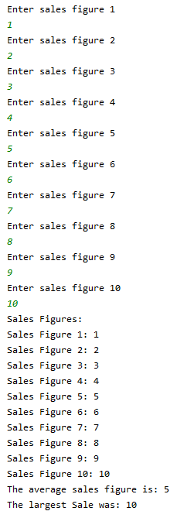

**Question 6**

Write an application containing an array that stores 5 prices, such as €2.34, €7.89 etc. The application should:

Read in the 5 numbers from the user

Display the sum of all the prices

Calculate and display the average of all the prices

Display all prices less than €5.00

Display all prices that are higher than the calculated average